* 2200030216 Additional handson task
* Demonstrate implementation of Query Methods feature of Spring Data JPA

Use this command on the vs code to run the spring application and get the output

mvn spring-boot:run

Dependencies needed to be added  
and keep you java at 17 in the pom.xml file or else you will get error

* + - 1. **Spring Boot Starter Web**
      2. 2. Spring Boot Starter Data JPA
      3. **3. H2 Database**
      4. **Spring Boot Starter Parent** (Defined in <parent>)

Next start your spring after you add the necessary dependencies  
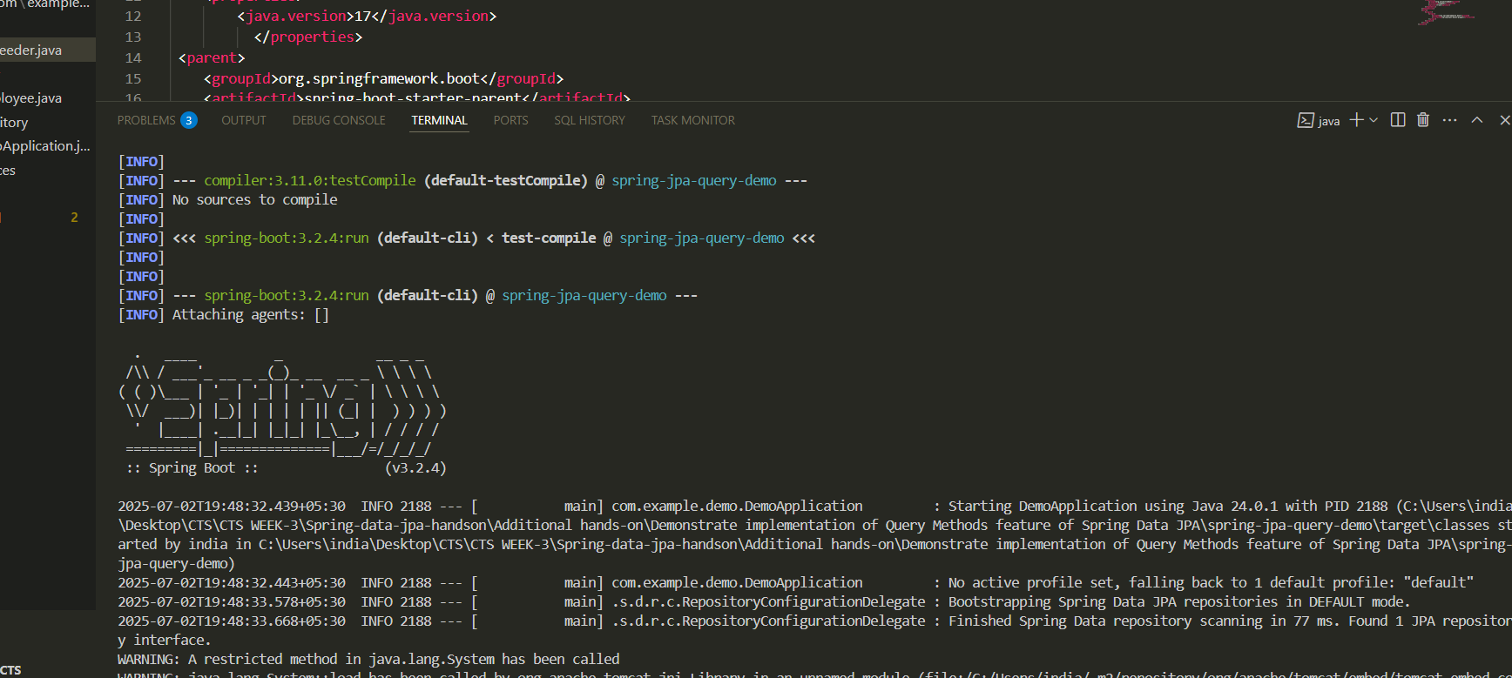

OUTPUT the data or the employees

